7. Interface Design Description
1. Login Screen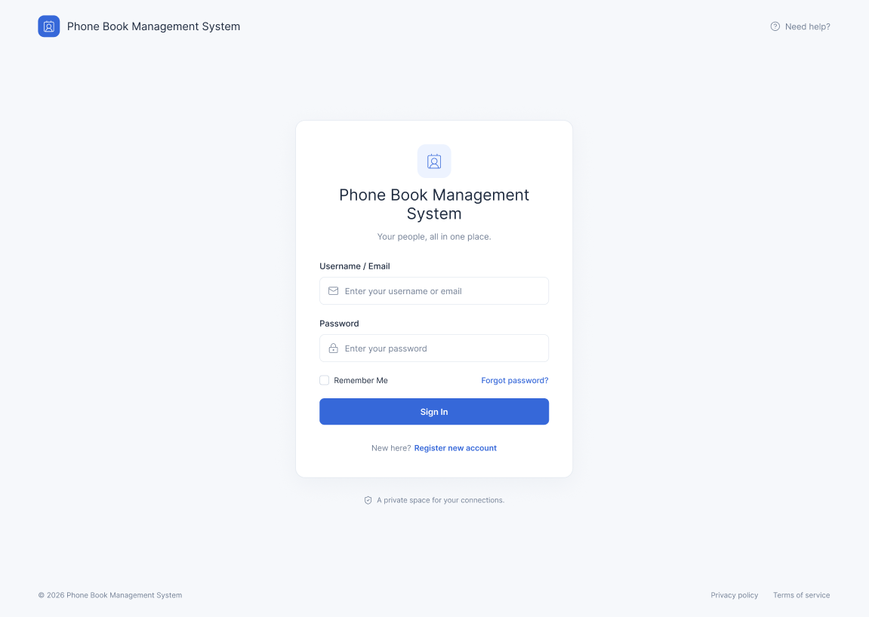
Allows users to enter their credentials (username/email and password) to authenticate and access the system, or navigate to registration and password recovery.

2.Forgot Password Screen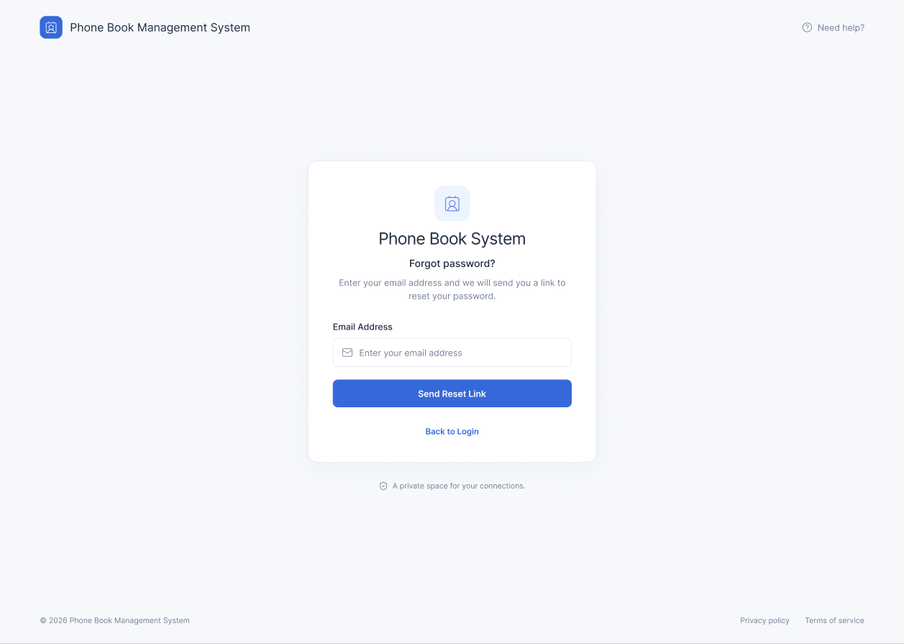
Allows users to request a password reset link by entering their registered email address

3.Register Screen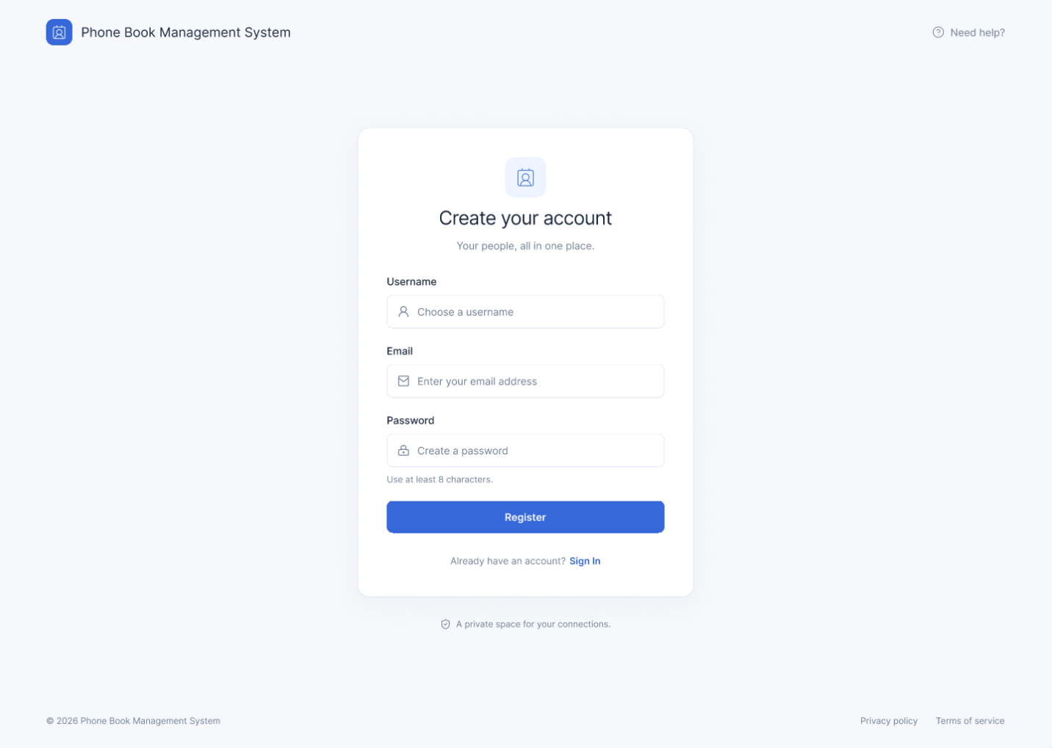
Enables new users to create an account by entering their username, email address, and password.
4. Contact List Dashboard 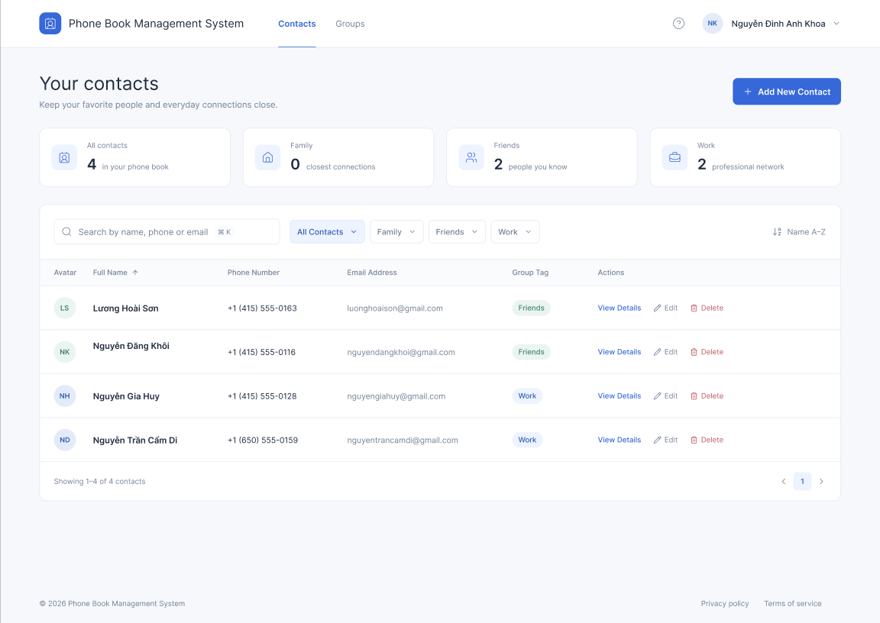
Displays the primary contact list sorted alphabetically (A–Z), featuring a search bar, group filtering options, and quick action buttons.
5.Group Management Screen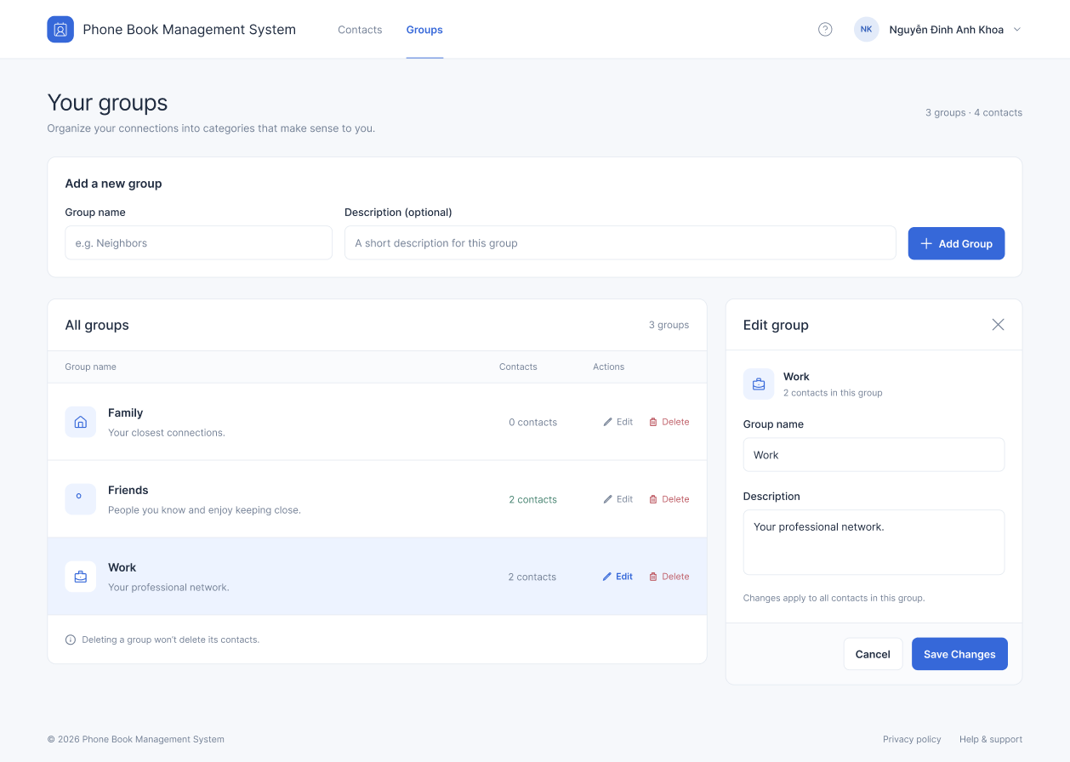
Allows users to create, view, edit, and delete contact categories (such as Family, Friends, or Work) to organize their phone book.
6.Advanced Search Screen 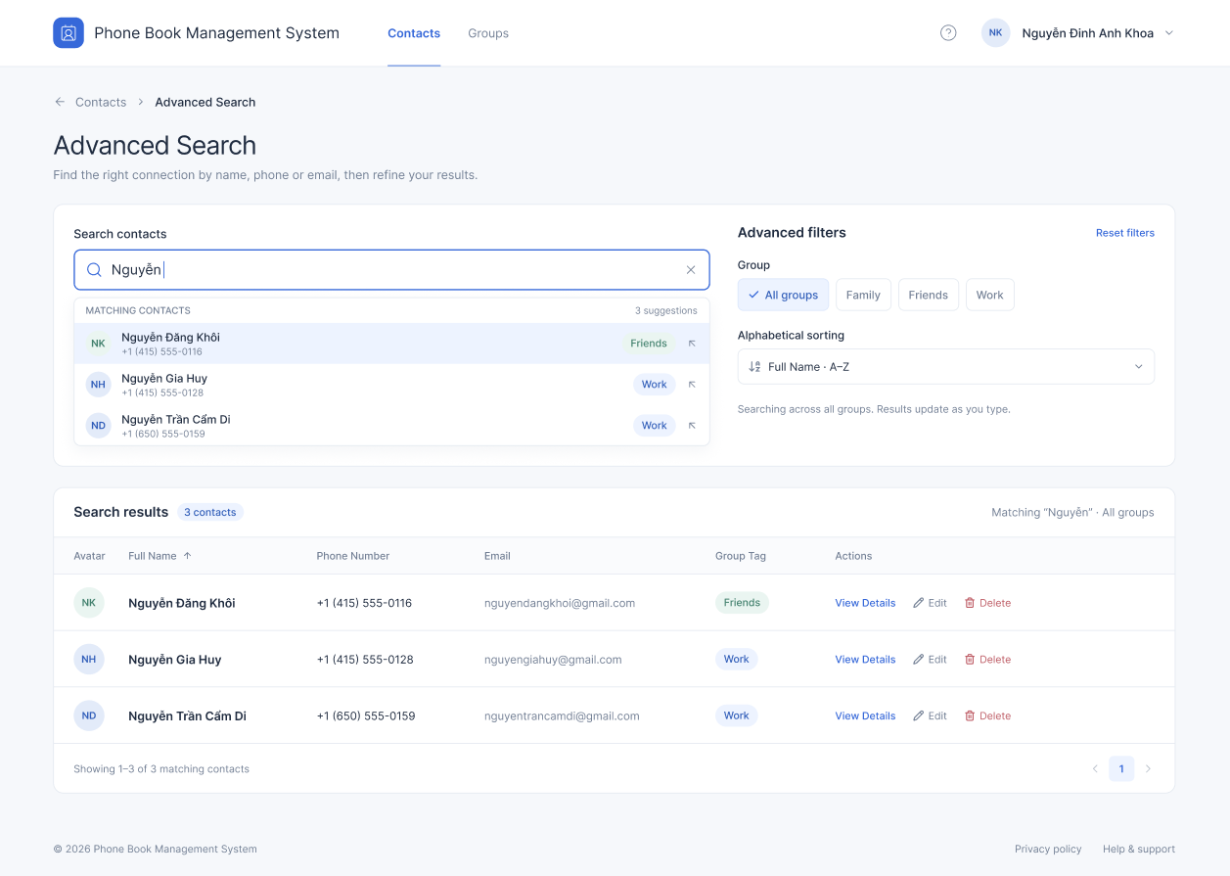
Provides filtering options by keyword, group category, and alphabetical sorting with real-time matching results.
7. Edit Contact Modal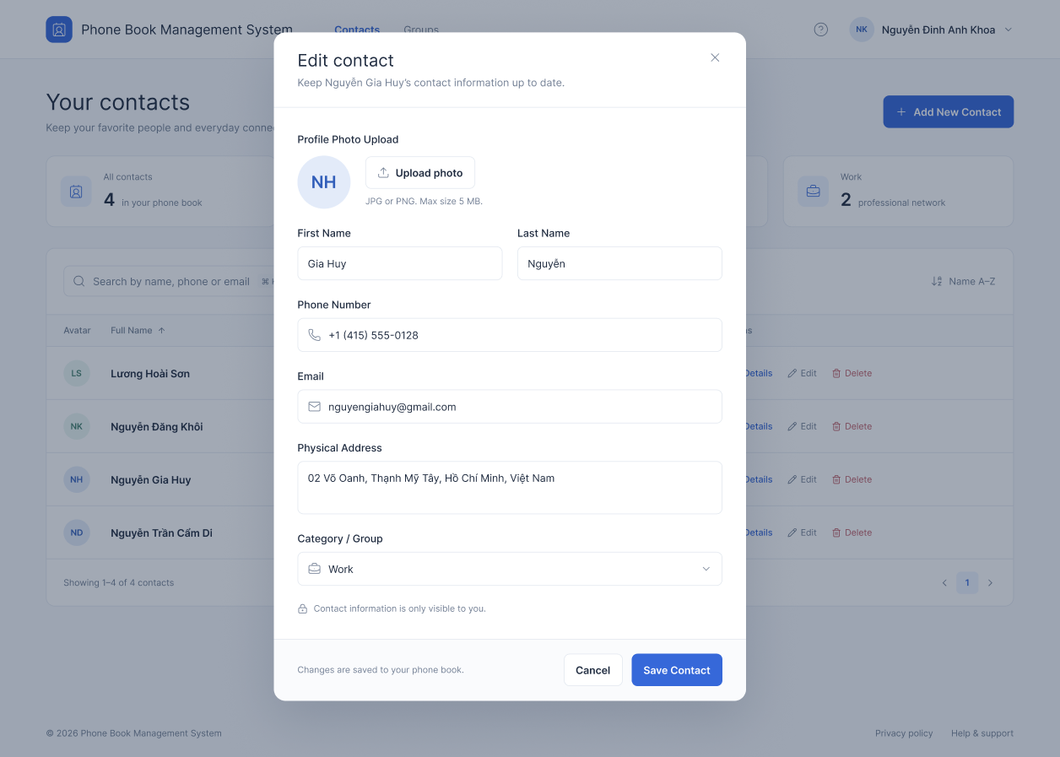
A pop-up form for adding or updating contact details, including name, phone number, email, address, and group category.
8. Contact Details Screen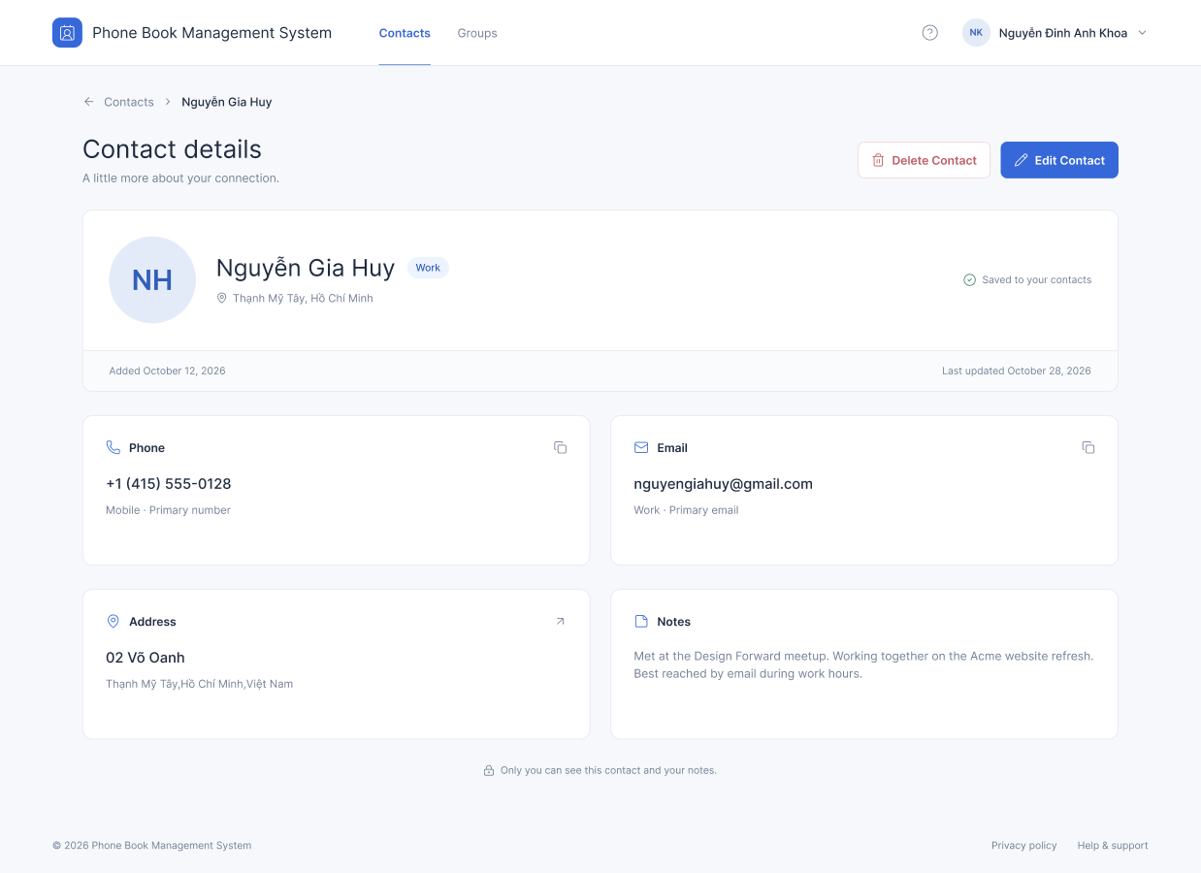
Displays comprehensive profile information of a selected contact, including phone number, email address, physical address, and personal notes.

9.Delete Confirmation Modal
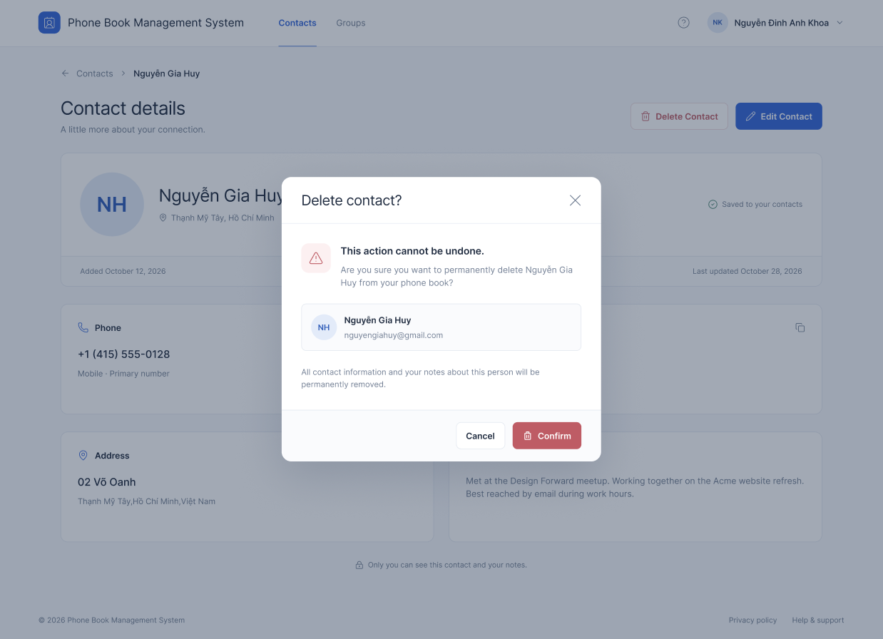
A pop-up modal warning users before permanently deleting a contact, providing summary info and "Cancel" or "Confirm" options.
https://www.figma.com/design/zCRlxv9t0IDWCc8giAzDIB/project?node-id=0-1&t=WzyjjrYt36CC5tGQ-1

